**ACCIDENT DETECTOR**

**END TERM PROJECT**

*BY*

|  |  |  |
| --- | --- | --- |
| NAME | SECTION | ROLL NO. |
| Tushar kasana | K18KY | 62 |
| Satyam sharma | K18KY | 64 |
| Abhishek tyagi | K18KY | 39 |



DEPARTMENT OF INTELLIGENT SYSTEM

DEPARTMENT OF COMPUTER SCIENCE AND ENGINEERING

LOVELY PROFESSIONAL UNIVERSITY, JALANDHAR

APRIL 2019-2020

STUDENT DECLARATION

This is to declare that this report has been written by us. No part of the report is copied from other sources. All information included from other sources have been duly acknowledged. We aver that if any part of the report is found to be copied, I/we are shall take full responsibility for it.

TUSHAR KASANA

ROLL NO: 62

SATYAM SHARMA

ROLL NO: 64

ABHISHEK TYAGI

ROLL NO: 39

PLACE: Lovely Professional University, Jalandhar

DATE: 07-April-2020

**TABLE OF CONTENTS**

|  |  |
| --- | --- |
| **TITLE** | **PAGE NO.** |
| 1.STUDENT DECLARATION | 2 |
| 2.BONAFIDE CERTIFICATE | 4 |
| 3. BACKGROUND AND OBJECTIVE OF THE PROJECT | 5-6 |
| 4. DESCRIPTION OF THE PROBLEM | 6-8 |
| 4.1 ABSTRACT |  |
|  |  |
| 4.2 CONSTRAINST |  |
|  |  |
| 4.3 ALGORITHM |  |
| 4.4 OUTPUT |  |
| 5. WORK DIVISION | 13-14 |
| 6. IMPLEMENTATION OF CODE | 15-17 |
| 7. TECHNOLOGY AND FRAMEWORK | 18 |
| 8. SWOT ANALYSIS | 19 |

BONAFIDE CERTIFICATE

Certified that this project report “INTELLIGENT TIME-TABLE PREPRATION” is the bonafide work of TUSHAR KASANA, SATYAM SHARMA, AND ABHISHEK KUMAR who carried out the project work under my supervision.

Supervisor: Ms. Shabnam

ID: 25660

Division of Admission

**BACKGROUND AND OBJECTIVES OF THE PROJECT**

Every day around the world, a large percentage of people die from traffic accident injuries. An influential indicator of survival rates after detecting the accident is the time between the occurrence of the accident and the arrival of emergency responders to the scene. Reductions in this time, in turn, may affect the numbers of fatalities, and this is achieved through using automatic traffic accident detection and notification systems which are either built-in the modern vehicles or available in the roads.

**Background:** Whenever accidents happen on the roads a lots of people die. Not just because of the Accidental injuries but also they die because they are not getting medical aid on time.So what our project basically does is that firstly it detects the accidents by the algorithm used and if the outcome of the result is in the favour of the accident it locates a shortest path for the nearest hospital and sends the alert to them so that they can give medical aid to the injured person in time.

**Motivation and Outcomes:** We created this project using DEEP LEARNING . There are many things that motivated us . Lets start with sone fact did you know there is one death in every 4 minutes in India. This is just the small number there is much bigger picture when we look in the whole world.what we expect from this project is much more it can used and fitted in every vehicle . It basically creates and analizes thousands of frames per minute in order to look for the similar characteristics of a accident.if it founds then only it sends a alert for the accident in order to get the medical aid to the injured person quickly.

**Goals and Objectives**: The main aim of the project Accident Detection and Messaging System is to inform the Ambulance and Police of the accident site and arrange for necessary steps to control the situation. This system is not only efficient but also worthy to be implemented. . The Accident Detection and Messaging System can be fitted in the CCTV camera or any other electronic equipments and they are informed about any such untoward incident at the go.Objectives are: If accident happens it tries to analyse it in order to figure out it’s a accident or not.after this finding a shortest path for the nearest hospital. After that sending An alert to all possible hospitals and ambulances that are nearest.

**DESCRIPTION OF PROJECT**

**Abstract**

Fatal road accidents can be easily analyzed by understanding the frame rate for a particular video of the accident.Majority of the accidents occur farther to the hospitals and people around panic and don’t know what to do and the person injured in the accident dies because of their lack of timely response.this project basically captures the video of a particular accident then divided it into thousands of frames to look for the accident and then sends an alert to the nearest ambulance or hospital by calculating shortest path.this project is basically done in DEEP LEARNING.

**Constraints**

When finding the probability of accidents the probability must not be greater than 1.

Distance must not be negative.

When finding shortest path the shortest path must not be equal to zero.

If probability is greater than 0.20 then only accident ALERT will be generated.

Algorithm

The algorithm is comprised in the following way:

1. **Loading and processing the video frames by opencv module**  
   Loads the video then divides it into thousands of frames for further code.
2. **Finding the probabilities**

Finding the probabilities of accident and non-accident and sends it to the further code.

1. **IF PROBABILITY OF ACCIDENT > 0.2**

**Sends the alert accident happened**

**Else sends accident not happened**

1. **FINDS THE SHORTEST PATH TO THE HOSPITAL**

**Then finds the shortest path to the nearest hospital and alerts nearest ambulances in order to give the injured person medical-Aid**

**5.displaying statistics and showing the result**  
In the final step,showing if the accident happened or not and have to send the warning alert or not.

**OUTPUTS:**

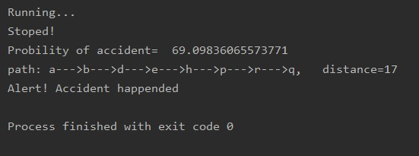

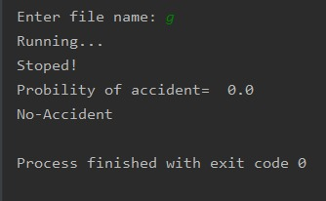

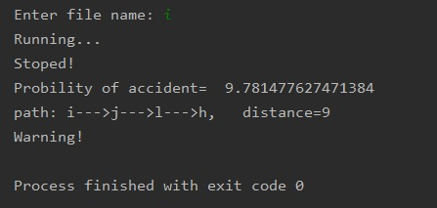

**WORK DIVISION**

**CONTRIBUTION IN PROJECT:**

1. **Group Member: Satyam sharma**

Accidental model was created by satyam sharma and all the opencv related work was done by him. Database for this model was created by him.And also probability calculation was done by him.

1. **Group Member : Tushar kasana**

Tushar basically created the code for finding the shortest path whenever the accident happen or ALERT goes off (DIJKSTRA ALGORITHM) for the backend of the model. Most of the research was done by him.

1. **Group Member : Abhishek tyagi**

All the remaining research work was done by abhishek .the videos was edited by him and also done some work in the opencv module.

**IMPLEMENTATION OF PROJECT**

**IMPORTING OPENCV MODULES AND SOME OTHER IMPORTANT MODULES**

**FOR THE PURPOSE OF SPLITTING THE VIDEO INTO THOUSANDS OF**

**FRAMES. ALSO FINDING THE PROBABILITY.**

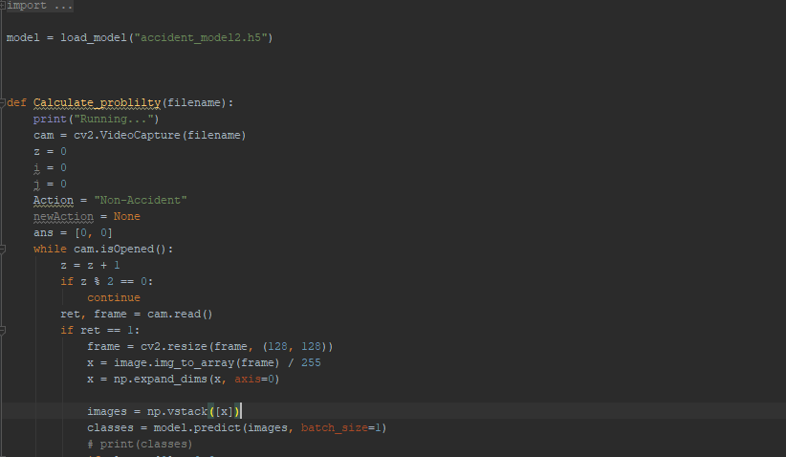

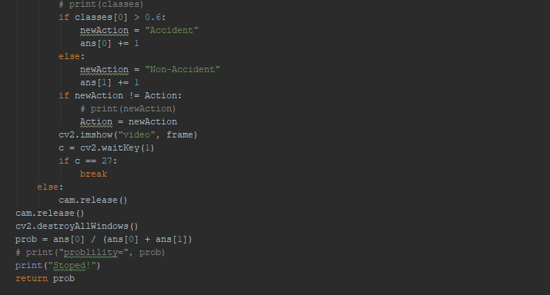

**NOW WE ARE USING DJKSTRA ALGORITHM FOR FINDING THE SHORTEST PATH TO A PARTICULAR HOSPITAL.**

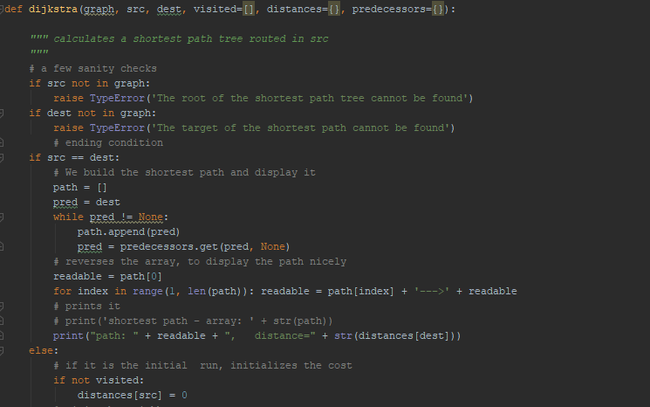

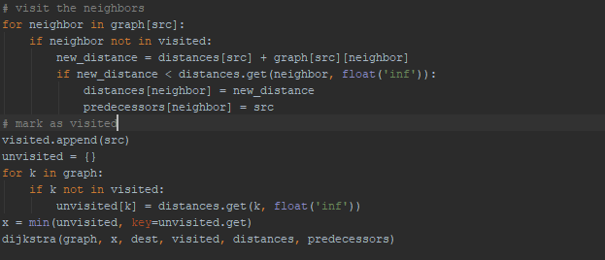

**AT LAST WE ARE CALLING THE MAIN FUNCTION TO SHOW US THE RESULTS OF OUR MODEL I.E. ACCIDEN HAPPENED OR NOT AND IF HAPPENED SENDING THE ALERT TO THE NEAREST AMBULANCE AND HOSPITALS.**

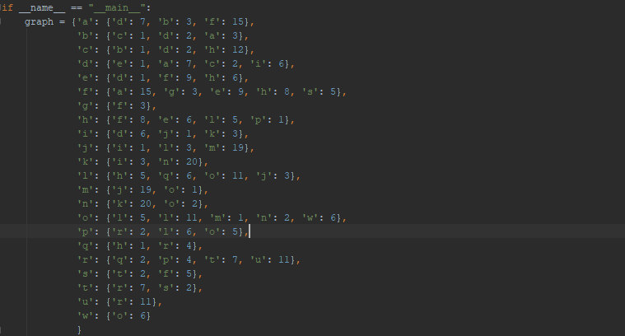

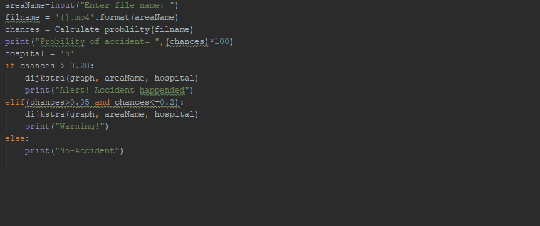

**TECHNOLOGY AND FRAMEWORK**

1.We have used computer Vision . Computer vision is not just a way to convert pictures to pixels, and it can’t make sense of a picture just from its pixels. It’s the ability of a machine to take a step back and interpret the big picture that those pixels represent.

2. Computer vision and Artificial intelligence (AI) is trailblazing its way into every walk of life and business. Companies that find ways to successfully merge AI with human interests will be responsible for building the next phase of the global economy.

3. We have used deep learning model to make this happen. **Deep learning** (also known as **deep structured learning** or **differential programming**) is part of a broader family of [machine learning](https://en.wikipedia.org/wiki/Machine_learning) methods based on [artificial neural networks](https://en.wikipedia.org/wiki/Artificial_neural_networks) with [representation learning](https://en.wikipedia.org/wiki/Representation_learning). Learning can be [supervised](https://en.wikipedia.org/wiki/Supervised_learning), [semi-supervised](https://en.wikipedia.org/wiki/Semi-supervised_learning) or [unsupervised](https://en.wikipedia.org/wiki/Unsupervised_learning).

4.We have created this model in PYCHARM COMMUNITY. The framework used here is python 3.7 for deeplearning.

**SWOT ANALYSIS**

In Earlier Times a lots of people die from accidents as they were not able to get medical-aid in time.So, keeping that in mind me and my team worked on this project .This project took nearly 20 exact days to be completed cause we had to analyse every aspect of accidents which are happening on the road. So we created a opencv module which can be installed on the traffic CCTV cameras and can detect whether an accident is happened on the road or not and does everything in order .Sends alerts to the nearest Ambulances and hospitals Also finds the shortest path for the particular hospital in order to get medical aid.